From: https://www.theverge.com/2019/4/13/18308652/katie-bouman-black-hole-science-internet
[Use the above when available to see more than the first visual and link to the Twitter site. –FNC]

Online trolls are harassing a scientist who helped take the first picture of a black hole
Black holes don’t suck, but sometimes the internet does
By Mary Beth Griggs Apr 13, 2019, 8:00am EDT

It’s so easy to be excited about Katie Bouman. She’s the 29-year-old computer scientist whose utter glee at seeing a black hole for the first time was captured in a picture that warmed hearts around the world.


MIT CSAIL
✔@MIT_CSAIL

Here's the moment when the first black hole image was processed, from the eyes of researcher Katie Bouman. #EHTBlackHole #BlackHoleDay #BlackHole (v/@dfbarajas)
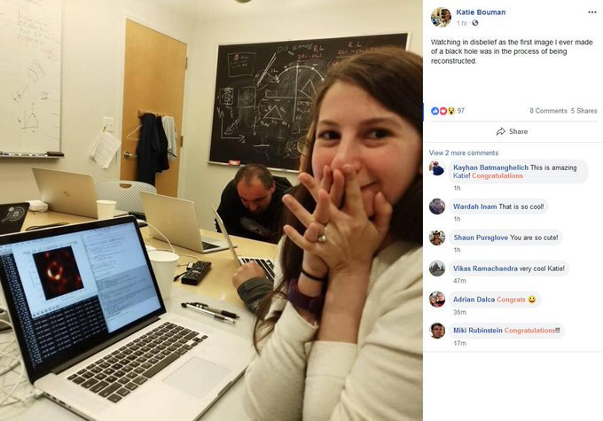

57.3K
12:51 PM - Apr 10, 2019
Twitter Ads info and privacy

Bouman, soon to be an assistant professor at Caltech, led one of the four teams tasked with turning data on half a ton of hard drives into the picture that ricocheted around the world on Wednesday.
Even with a picture right there on our screens, actually understanding something larger than our solar system and 6.5 billion times more massive than our Sun was still nearly impossible. But joy is easy for humans to understand — and so that perfectly timed picture of her with her hands over her mouth drew us in.
A Twitter account associated with her alma mater, MIT, was one of the first to congratulate her for the work, saying: “3 years ago MIT grad student Katie Bouman led the creation of a new algorithm to produce the first-ever image of a black hole. Today, that image was released.” The account linked to a 2016 story about Bouman developing an algorithm for the project. But if you were reading Twitter quickly, basking in the glow of a thousand eyes of Sauron, you might have inferred — as many did — that MIT was saying her algorithm alone led to the creation of that image. (They’ve since posted more tweets emphasizing that Bouman and her work were part of a collaboration.)
People took notice. Journalist Flora Graham compared a picture of Bouman with some of the hard drives used on the project to an image of Margaret Hamilton, a computer scientist whose code was crucial to the Apollo missions. Congratulations poured in, and Bouman’s popularity accelerated. For some people, it was easier to relate to one delighted human face than two hundred smaller smiling faces and names.
Within a few hours, the gravitational well of darkness that is the internet began to tug on her. Her phone started getting so many messages that she had to shut it off, according to The New York Times. Someone repeatedly set up fake Twitter accounts in her name. The next day, the Times published an article called “How Katie Bouman Accidentally Became the Face of the Black Hole Project”. The Verge reached out to Bouman for comment, but a representative of MIT told The Verge that Bouman was not speaking to the press at the moment.
It’s wonderful to be recognized for your work. But it must also be uncomfortable to stand in a spotlight and be asked to take a final bow for your starring role when you were part of an ensemble cast.
In response to the attention, Bouman wrote in a Facebook post: “No one algorithm or person made this image, it required the amazing talent of a team of scientists from around the globe and years of hard work to develop the instrument, data processing, imaging methods, and analysis techniques that were necessary to pull off this seemingly impossible feat. It has been truly an honor, and I am so lucky to have had the opportunity to work with you all.”
It’s the internet; things got worse. In what can only be described as a sexist scavenger hunt, people began going over her work to see how much she’d really contributed to the project that skyrocketed her to unasked-for fame. The trolls focused in on one of her colleagues, Andrew Chael, who was listed on GitHub as the primary developer for one of the algorithms that revealed the black hole, and started circulating his picture instead. Chael was having none of it.
“It was clearly started by people who were upset that a woman had become the face of this story and decided, ‘I’m going to find someone who reflects my narrative instead,’” Chael told The Washington Post.
In addition to Twitter, trolls have been putting videos on YouTube spreading rumors about her work, and creating fake accounts on Instagram targeting Bouman and Chael. As Ben Collins noted at NBC, “the situation highlighted the vitriol that women continue to face on the internet, and the continued vulnerability of major internet platforms to trolling campaigns.”
This isn’t just an online trend. Women in science are cited less than their male colleagues. They have a harder time getting work published in notable journals, including the flagships Science and Nature. They are likely paid less than their peers (a 2013 study found that women working in physics and astronomy were paid 40 percent less than men). And they are more likely to face workplace harassment.
The internet doesn’t exist in a vacuum; part of the reason that some posters found Bouman immediately suspicious had to do with her gender. Famously, a number of prominent men like disgraced former CERN physicist Alessandro Strumia have argued that women aren’t being discriminated against in science — they simply don’t like it, or don’t have the aptitude for it. That argument fortifies a notion that women don’t belong in science, or can’t really be doing the work. So women like Bouman must be fakes, this warped line of thinking goes. [Reference Larry Summers.]
This particular problem won’t vanish after this news cycle passes, though there are some glimmers of positive changes within the scientific community. Researchers are protesting grant processes that overwhelmingly fund male-led projects, and scientific societies are reforming their sexual harassment policies.
But part of the problem is how Bouman came to be a synecdoche for the work of a huge team. Science is being done on bigger scales now, which is allowing us to begin answering questions our ancestors would never have dreamed of. Those answers are thanks to the combined efforts of inspiring people like Katie Bouman, Andrew Chael, Shep Doeleman, Kazu Akiyama, and their other 200 or so colleagues. It’s hard to hold 215 people’s names and faces in your head. It’s easy to remember one delighted face in a photo.
[Reference below, at bottom, the Dwight Eisenhwer Farwell Address [Threat 2, scientific-technological elite] ]
It’s wonderful that we got to hear Bouman’s story. It’s awful that people would attack Bouman’s credibility because her story was told. And it’s also true that she alone doesn’t carry the entire weight of this amazing scientific work on her shoulders alone.
Saying that she was part of a larger team doesn’t diminish her work, or minimize her involvement in what is already a history-making project. Highlighting the achievements of a brilliant, enthusiastic scientist does not diminish the contributions of the other 214 people who worked on the project, either. But what it is doing is showing a different model for a scientist than the one most of us grew up with. That might mean a lot to some kids — maybe kids who look like her — making them excited about studying the wonders of the Universe.
The internet can be dark; it can be heavy; it might be full of garbage. But only black holes can make light vanish. Bouman has a strong start on her career — we’ll be lucky to see what she does next.
Correction 4/12/19: This article had been updated. Bouman will be an assistant professor at Caltech, not an associate professor. We regret the error.

APPENDIX
Eisenhower
[Threat 2, scientific-technological elite] Akin to, and largely responsible for the sweeping changes in our industrial-military posture, has been the technological revolution during recent decades.
In this revolution, research has become central; it also becomes more formalized, complex, and costly. A steadily increasing share is conducted for, by, or at the direction of, the Federal government.
Today, the solitary inventor, tinkering in his shop, has been overshadowed by task forces of scientists in laboratories and testing fields.^{[6]} In the same fashion, the free university, historically the fountainhead of free ideas and scientific discovery, has experienced a revolution in the conduct of research. Partly because of the huge costs involved, a government contract becomes virtually a substitute for intellectual curiosity. For every

1038
Page 1039 Dwight D. Eisenhower, 1960 Document 421

old blackboard there are now hundreds of new electronic computers.
The prospect of domination of the nation's scholars by Federal employment, project allocations, and the power of money is ever present - and is gravely to be regarded.^{[7]}
Yet, in holding scientific research and discovery in respect, as we should, we must also be alert to the equal and opposite danger that public policy could itself become the captive^{[8]} of a scientific-technological elite.^{[9]}
It is the task of statesmanship to mold, to balance, and to integrate these and other forces, new and old, within the principles of our democratic system-ever aiming toward the supreme goals of our free society.

